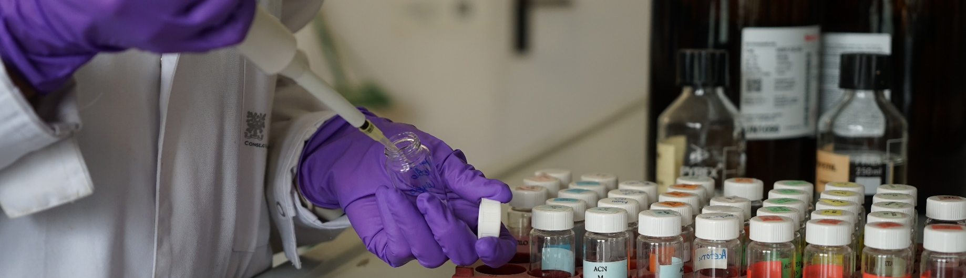
PhD fellowship

The institute
The Institute of Environmental Assessment and Water Research (IDAEA) is an environmental science institute devoted to the study of the human footprint on the biosphere. Much of the research work at this institute is centred on two of the great environmental challenges of our time: cleanliness and availability of water and quality of air.
Founded in 2008 as a member of the Spanish National Research Council (CSIC), the Institute brings together a wide range of expertise in environmental science. It is organized under two Departments (Environmental Chemistry and Geosciences), established with a strong record of publication in top scientific journals, leading international projects, membership on international committees, and adopting a high-profile contribution to the identification and remediation of environmental problems.
IDÆA has demonstrated strengths in the analysis of organic pollutants and their impact on ecosystems, the study and management of water resources, the development of multivariate resolution algorithms in chemometrics, and in the study of inhalable particulate matter and toxic gases.
IDÆA has been recently awarded with the distinctive Centre of Excellence “Severo Ochoa” (2020-2023), distinction that indicates the high-quality scientific leadership and global impact of the work developed at the centre.
We offer a diverse and inclusive environment where no discrimination against disability, gender, nationality, religion or sexual orientation will occur during the selection process.

The group
The Environmental Geochemistry and Atmospheric Research (EGAR) group is specialized in air quality assessment and monitoring, using state of the art air pollutant instrumentation combined with innovative monitoring strategies based on sensor networks. The team has strong expertise in source apportionment to aid in the identification of major sources impacting air quality degradation, which in turn supports the implementation of mitigation strategies. Similarly, EGAR is experienced in health impact assessment to translate air pollution impacts into premature mortality and morbidity outcomes, easier to understand by the general population. This combination of monitoring tools and methodologies provides the ideal framework to assess the effectiveness of innovative air quality monitoring and modelling tools.
The EGAR team has a fully equipped and running laboratory for air quality monitoring. Instruments available for the proposal are high-volume samplers, stationary and portable cascade impactors (ELPI+, Berner, PCIS), particle counters and sizers (CPC, NanoScan, SMPS), handheld particle number and black carbon monitors (DiscMini, AE51), one nanoparticle aerosol sampler (NAS), portable gaseous monitors (CO, CO2), and full facilities for particle characterisation in the lab (ICP-MS, ICP-AES, ion chromatography), and receptor modelling expertise for source apportionment analysis.
The role
PhD student
Field of research: Air pollution from road traffic; impact of electrification
Research project: Non-exhaust emissions from road transport- impact on air quality, health and the implications of electric vehicles uptake.
The project includes collaboration and short-stays of the selected candidate at big enterprises of the automotive industry and air pollutants monitoring, as well as leading international research institutions.
What do we look for?
- Qualifications
M.Sc. (completed or in course) in Environmental Engineering, Physics, Chemistry, Geology, Mathematics or similar
- Professional experience
No specific professional experience is required.
- Competences
High level of English, availability to travel abroad during several weeks
Value will be given to candidates with:
- High motivation, initiative and independence
- Good team-working skills
- Programming skills

Working conditions
- Full-time contract
- Target start date: Flexible

How to apply?

Those interested may email their CV and motivation letter to Dr. Fulvio Amato at fulvio.amato@idaea.csic.es adding “PhD position” to the email subject.

